https://discord.com/channels/1426767641367941134/1452547282405691474/threads/1460964929421967537

https://www.forexfury.com/best-forex-robot-2026-core-update/

https://www.forexfury.com/forex-fury-v6-the-best-bot-gets-better/
TWP Robot Settings – Index
Basic Setup & Identification
Username & TOS
- 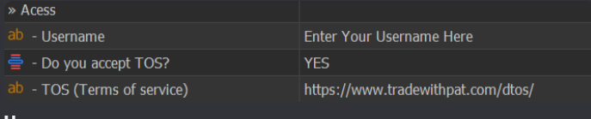
- Username: Enter your username exactly as it appears on the TWP website. The username is case-sensitive, so make sure all letters (including capital letters) match perfectly. If the username is entered incorrectly, the robot will fail to authenticate and will not run. TOS (Terms of Service): Set this option to YES to confirm that you agree to the TWP Terms of Service. The robot will remain inactive if this option is not accepted.
- Magic Number
- 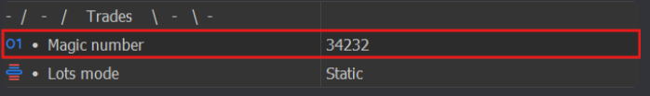
- The Magic Number is a unique identification number that MetaTrader uses to recognize which trades belong to a specific EA or a specific EA setup. Each EA, or each instance of the same EA running with different settings, should have its own Magic Number. This helps MetaTrader correctly separate and manage trades. If two EAs (or two setups) use the same Magic Number, MetaTrader may mix the trades, and one EA could attempt to manage, modify, or close trades that were opened by another EA. For this reason, always assign unique Magic Numbers, especially when running multiple charts, multiple strategies, or multiple instances of the TWP Robot.
- Risk & Position Sizing

Lot Mode & Lot Size
- 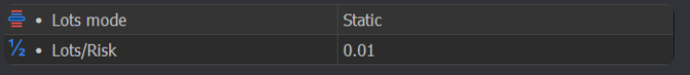
- The Lot Mode setting controls how the TWP Robot calculates trade volume (lot size). The value entered in “Lots/Risk” is interpreted differently depending on the selected lot mode. ---
Static

In Static mode, every trade uses a fixed lot size. How it works:
  - The value set in “Lots/Risk” is used directly as the lot size
  - Lot size does not change, even if the account balance grows or decreases

Example:
  - Lots Mode: Static
  - Lots/Risk: 0.10

Every trade will be opened with 0.10 lot, regardless of whether the balance is $1,000 or $50,000. ---
Dynamic (% of Balance)

In Dynamic mode, the lot size is calculated based on a percentage risk of the account, using the highest equity achieved since the EA was activated. How it works:
  - The value in “Lots/Risk” represents the risk percentage
  - As the account grows, the lot size increases automatically

Example:
  - Account balance: $10,000
  - Highest equity : $12,000
  - Lots/Risk: 1 (%)

The robot calculates position size so that 1% of $12,000 is at risk per trade, adjusting the lot size automatically.
- ---
1 Lot per X Balance

In this mode, the lot size is calculated purely based on account balance, without considering stop-loss distance or risk per trade. How it works:
  - The robot divides the account balance by the value set in “Lots/Risk”
  - The result is used as the lot size
  - Lot size increases automatically as the balance grows

Examples: Example 1: Larger lot sizing
  - Account balance: $10,000
  - Lots/Risk: 1,000

Lot size = 10,000 ÷ 1,000 = 10.00 lots Example 2: Smaller lot sizing
  - Account balance: $10,000
  - Lots/Risk: 100,000

Lot size = 10,000 ÷ 100,000 = 0.10 lot (Equivalent to 0.01 lot per $1,000) ---
Key Difference Summary
  - Static: Fixed lot size, no compounding
  - Dynamic (%): Risk-based, smart compounding, equity-aware
  - 1 Lot per X Balance: Balance-based, simple compounding, no risk calculation

Lots Multiplier After Loss (Martingale)
- This setting defines a risk or lot size multiplier applied after a losing trade. When enabled, the EA will increase the risk or lot size for the next trade by the specified multiplier following a loss. Each consecutive loss compounds the effect.
  - Example logic: If your initial risk is 0.1% and the multiplier is set to 2.0:
    - After 1 loss → risk increases to 0.2%
    - After 2 losses → risk increases to 0.4%
This feature works with both dynamic (risk-based) and fixed lot settings. However, it does not work when grid trading is enabled, as grid logic manages position sizing differently. This option should be used carefully, as increasing risk after losses can accelerate drawdowns if market conditions remain unfavorable.

Stop Loss, Take Profit & Volatility
SL Mode (Stop Loss Method)
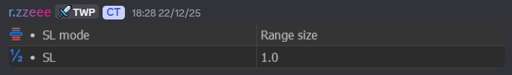
- The SL Mode defines how the TWP Robot calculates the Stop Loss level for each trade. Depending on the selected mode, the value entered in “SL” will be interpreted as points, an ATR multiplier, or a range-based multiplier. ---
Points
Simple fixed Stop Loss The Stop Loss is placed at a fixed distance from the entry price using the number of points defined in “SL”. This method does not adapt to market volatility. ---
ATR
Volatility-based Stop Loss The Stop Loss distance is calculated using ATR × SL. This allows the Stop Loss to automatically adjust based on current market volatility (higher volatility = wider SL). ---
Range Size
Range-based Stop Loss The EA calculates the ORB range size and multiplies it by the value set in “SL”. The resulting distance is used to place the Stop Loss. ---
Previous Candle + Points
Candle-structure Stop Loss (fixed buffer) The Stop Loss is placed at the High or Low of the previous candle (based on trade direction), plus the number of points defined in “SL”. ---
Previous Candle + ATR
Candle-structure Stop Loss (volatility-adjusted) The Stop Loss is placed at the High or Low of the previous candle (based on trade direction), plus a distance calculated using ATR. ---
Last Swing + Points
Market-structure Stop Loss (fixed buffer) The Stop Loss is placed at the most recent swing high or swing low on the EA’s timeframe, plus the number of points defined in “SL”. ---
- Last Swing + ATR
Market-structure Stop Loss (volatility-adjusted) The Stop Loss is placed at the most recent swing high or swing low, plus a distance calculated using ATR. Last Swing Definition: The Last Swing is the most recent price reversal point identified on the chart, represented by the last valid fractal, where a clear change in price direction occurred. ---
Range Opposite + Points
Opposite-side range Stop Loss (fixed buffer) If a trade is opened at the top of the ORB range, the Stop Loss is placed at the bottom of the range, plus the number of points defined in “SL”, and vice versa. ---
Range Opposite + ATR
Opposite-side range Stop Loss (volatility-adjusted) If a trade is opened at the top of the ORB range, the Stop Loss is placed at the bottom of the range, plus a distance calculated using ATR, and vice versa. ---
SL (Value Field)
The SL field defines the size or multiplier used by the selected SL Mode:
  - In Points mode, it represents Stop Loss distance in points
  - In ATR modes, it represents the ATR multiplier
  - In Range Size modes, it represents the range multiplier
The meaning of this value changes based on the selected SL Mode, so it must be set accordingly.

TP Mode (Take Profit Method)
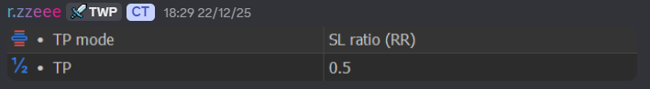
- The TP Mode defines how the TWP Robot calculates the Take Profit level for trades. Based on the selected mode, the value entered in “TP” will be used differently to determine the TP distance. ---
SL Ratio
Stop Loss–based Take Profit The Take Profit is calculated as a multiple of the Stop Loss size. The robot takes the current SL distance and multiplies it by the value set in “TP”. This method keeps a fixed risk-to-reward ratio for every trade. ---
ATR
Volatility-based Take Profit The Take Profit distance is calculated using ATR × “TP”. This allows the TP to automatically adapt to market volatility, expanding during high volatility and contracting during low volatility. ---
Points
Fixed Take Profit The Take Profit is placed at a fixed distance from the entry price using the number of points defined in “TP”. This method does not adjust to market conditions. ---
TP (Value Field)
The TP field defines the ratio, multiplier, or points used by the selected TP Mode:
  - In SL Ratio mode, it represents the R:R ratio
  - In ATR mode, it represents the ATR multiplier
  - In Points mode, it represents the TP distance in points
The meaning of this value depends entirely on the selected TP Mode, so it must be configured accordingly.

ATR Period & ATR Timeframe
- ATR (Average True Range) is a volatility indicator that measures how much the market is moving over a given period. The TWP Robot uses ATR to adapt Stop Loss, Take Profit, and grid-related calculations based on current market conditions. ---
ATR Period
The ATR Period defines how many candles are used to calculate the ATR value.
  - A lower period reacts faster to recent price movements
  - A higher period produces smoother, more stable values
This setting controls how sensitive the robot is to changes in volatility. ---
ATR Timeframe
The ATR Timeframe specifies which timeframe the ATR is calculated from. This is independent of the chart or EA timeframe, meaning:
  - The EA can trade on one timeframe
  - While ATR is calculated from another timeframe
Using a higher ATR timeframe results in more stable, less reactive volatility measurements, while a lower timeframe makes the robot respond faster to short-term volatility changes. ---
Important Note
ATR does not predict market direction. It only measures market volatility, which the robot uses to dynamically adjust its trade management logic.

Sessions, Time & Ranges
Trading Session & DST
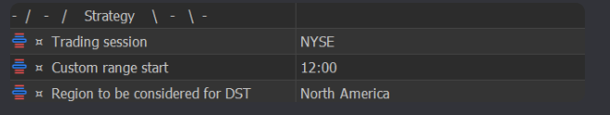
Trading Session
This setting defines which trading session marks the beginning of the monitoring range for the TWP Robot. Currently, the robot offers five predefined sessions, along with an option to define a custom session start time. Available sessions:
- American Session: 8:00 EST | 12:00 GMT
- NYSE Session: 9:30 EST | 13:30 GMT
- European Session: 3:00 EST | 7:00 GMT
- London Session: 4:00 EST | 8:00 GMT
- Asian Session: 19:00 EST | 00:00 GMT
Custom Session Start: This option allows you to manually set a specific session start time if you want the monitoring range to begin at a non-standard market opening. ---
DST (Daylight Saving Time)
The DST option is used to select the Daylight Saving Time region of the trading exchange location. This ensures session start times remain accurate when daylight saving changes occur. Important guidelines:
- If you are using a provided set file, keep the DST setting exactly as defined in the set file
- Only change the DST setting when manually configuring session times
- When adjusting DST manually, select the following:
  - NYSE / American sessions → North America
  - European / London sessions → Europe
  - Asian session → No DST
Using the correct DST setting ensures the robot’s session timing stays aligned with real market hours throughout the year
Custom Range.
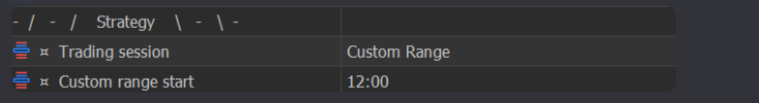
- The Custom Range option allows you to define your own session start time instead of using one of the predefined trading sessions. When Session = CUSTOM RANGE, the robot will ignore standard session opens and instead begin monitoring the market at the time specified in “Custom Range Start”. This setting is useful if you want the EA’s range calculation to start at a specific hour that better suits your strategy or market behavior. To use this correctly:
  - Set Trading Session to CUSTOM RANGE
  - Define the desired session start time in Custom Range Start
Once configured, the robot will treat this custom time as the official beginning of the monitoring range.

Monitoring Range & Trading Range
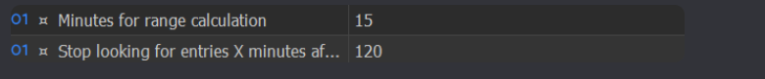
Minutes for Range Calculation
This setting defines how long (in minutes) the EA will monitor price movement and build the ORB range after the selected trading session begins. During this period:
- The EA does not place trades
- It only observes price action to determine the high and low of the range
Once this time window ends, the range is considered fixed and completed. ---
Stop Looking for Entries X Minutes After Range Completion
This setting defines how long the EA is allowed to search for trade entries after the monitoring range has been completed. After the specified number of minutes:
- The EA will stop opening new trades
- The previously calculated range remains valid
- Trade management (if already in trades) continues as per strategy rules
---
Key Concept
- Monitoring Range: Time used to build the ORB range
- Trading Range: Time used to trade within that completed range
These two settings together control when the EA observes and when it actively trades.

Max Trade Holding Time
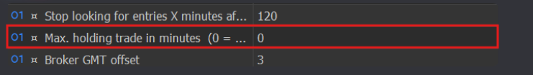
- Max. Holding Trade in Minutes (0 = Disabled) This setting defines the maximum amount of time, in minutes, that a trade is allowed to remain open.
  - If a trade stays open longer than the specified time, the EA will automatically close the trade
  - Setting this value to 0 disables the feature, allowing trades to remain open until they are closed by TP, SL, or other logic
This option is mainly used to limit exposure, avoid prolonged trades, and prevent positions from remaining open beyond the intended trading window.

GMT Offset
- MetaTrader is unable to detect the true GMT correctly during backtesting, and relying only on historical broker data to calculate GMT automatically can be unreliable. For this reason, it is safer to manually set the GMT Offset when running backtests. It is also important to note that some brokers have changed their GMT offset at different points in historical data, which can affect the accuracy of backtesting results if GMT is not set correctly. For live trading, the TWP Robot automatically selects the correct time for each trading session, so no manual GMT adjustment is required. For backtesting, you must adjust the GMT Offset manually to match your broker’s server time. A detailed, step-by-step explanation on how to do this is provided in the Backtesting guide included in the robot’s downloaded ZIP file.

EA Timeframe
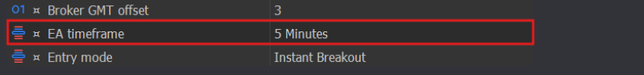
- The EA Timeframe defines the timeframe the TWP Robot uses for its entry logic and all internal calculations. This setting is independent of the chart’s timeframe, meaning the timeframe you attach the EA to does not affect how the robot operates. The EA will always follow the timeframe selected in this option for entries, structure, and decision-making.
- Entry Logic
Entry Mode
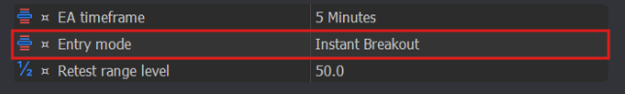
- The Entry Mode defines how and when the TWP Robot opens trades based on price interaction with the calculated range. All entry logic is based on the EA Timeframe, not the chart timeframe. ---
Breakout
  - A trade is opened after a candle closes outside the range
  - The trade is placed in the direction of the breakout
  - The breakout candle must meet the minimum body size defined in Breakout min. body candle (ATR)
  - Setting the minimum body size to 0 disables this filter
This mode is designed to trade confirmed range breaks. ---
Instant Breakout
  - A trade is opened immediately when price touches the range high or low
  - No candle close is required
  - The trade is placed in the direction of the tested range side
This mode is more aggressive and reacts instantly to price interaction with the range. ---
Retrace
  - A trade is opened after a candle closes outside the range
  - The trade is placed in the opposite direction of the breakout
  - The breakout candle must meet the minimum body size defined in Breakout min. body candle (ATR) unless disabled
This mode assumes the breakout will fail and reverse. ---
Instant Retrace
  - A trade is opened as soon as price touches the range boundary
  - No candle close is required
  - The trade is placed in the opposite direction of the tested range side
This mode anticipates immediate rejection at the range boundary. ---
- Retest Range – Same Direction
  - Price first breaks one side of the range
  - Price then returns to retest the range
  - The trade is triggered when a candle closes back inside the range
  - The trade is placed in the same direction as the first breakout
This mode is based on the expectation of a pullback after a breakout. ---
Retest Range – Opposite Direction
  - Price first breaks one side of the range
  - Price then returns and breaks the opposite side of the range
  - The trade is taken in the direction of the first breakout, which is opposite to the second breakout
This mode assumes a false breakout followed by a trap and continuation. ---
Retest Range Level X
  - Trades are based on a dynamic internal level inside the range
  - A prior breakout is required:
    - For buy trades, price must have previously broken above the upper boundary of the range
    - For sell trades, price must have previously broken below the lower boundary of the range
  - The trade entry is triggered when the previous candle opens on one side of the defined level and closes on the opposite side
  - The trade is placed in the direction of the initial breakout
This mode uses internal range levels after a confirmed breakout, allowing entries at customized positions between Range High and Range Low while maintaining directional bias from the breakout. ---
- FVG and Supply & Demand
Refer to the PDF guide below
Related Entry Settings
Retest Range Level
Defines the percentage level (%) used as the reference for Retest Range Level X entries. ---
Retest Max. Body Candle (ATR)
For all Retest modes:
  - The candle that triggers the trade must have a body size smaller than the value configured here (in ATR)
  - This helps filter out high-momentum candles and improves retest quality
---
Breakout Min. Body Candle (ATR)
Defines the minimum candle body size (in ATR) required for Breakout and Retrace entry modes. Setting this value to 0 disables the filter. ---
Supply & Demand Min. Candles
Refer to the PDF guide below. ---
FVG – Aggressive Push Setup (% Range Size)
Refer to the PDF guide below

Filters & Trade Limits
Max Trades Filter
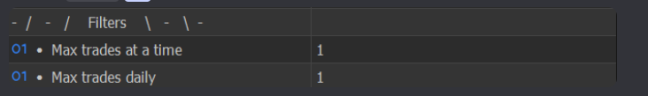
The Max Trades Filter is used to control and limit how many trades the EA is allowed to open, helping manage risk and overtrading. These limits apply only to trades opened by the EA and do not consider manual trades or trades from other EAs. Important note: Additional trades opened as part of the Grid system do not count toward these limits. ---
Max Trades at a Time
This setting limits the maximum number of active (open) trades the EA can have at the same time. Once this limit is reached:
- The EA will not open new trades
- Existing trades will continue to be managed normally
---
Max Trades Daily
This setting limits the total number of trades the EA can open in a single day. Once the daily limit is reached:
- The EA will stop opening new trades for that day
- Trade management for already open trades continues as usual
This option is useful to cap daily activity and avoid overtrading

Max Spread Filter
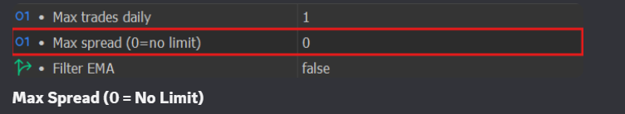
- Max Spread (0 = No Limit) This setting limits the maximum allowed spread for opening a new trade.
  - The EA will only open trades when the current spread is equal to or below the value set here
  - If the spread is higher, the EA will skip the entry
  - This filter applies only to initial trade entries and does not affect grid trades
Setting this value to 0 disables the spread filter, allowing trades regardless of spread conditions. This option helps avoid entries during high-spread situations such as low liquidity periods or news events.

EMA Filter
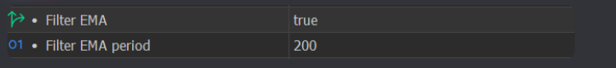
- The EMA Filter is a trend-confirmation filter used to ensure trades are aligned with the prevailing market direction. When enabled, the EA checks whether the price is above or below the EMA:
  - If the trade direction matches the EMA trend, the trade is allowed
  - If the trade direction does not match the EMA trend, the trade is blocked
The EMA Period defines how sensitive the EMA is:
  - A lower period reacts faster to price changes
  - A higher period represents a smoother, longer-term trend
You can enable or disable the EMA filter and adjust its period depending on how strictly you want the EA to follow the trend.

S/R (Support & Resistance) Filter
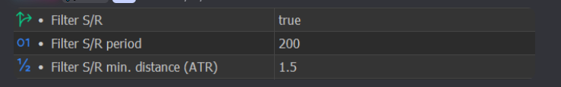
- The S/R Filter is used to avoid opening trades too close to key support or resistance levels, where price is more likely to stall or reverse. ---
Filter S/R
Enables or disables the Support & Resistance filter. ---
Filter S/R Period
Defines the period used to identify S/R levels. ---
Filter S/R Min. Distance (ATR)
Sets the minimum allowed distance, measured in ATR, between the current price and the most recent S/R level. If the price is closer than this distance, the EA will block the trade. ---
How S/R Is Defined
The S/R levels are calculated using the last Bill Williams Fractals price, which represents recent swing highs or swing lows on the chart. If the current price is too close to this fractal-based S/R level (based on the ATR distance you define), the EA assumes there is insufficient room for price movement and avoids opening the trade.

Supply & Demand Filter
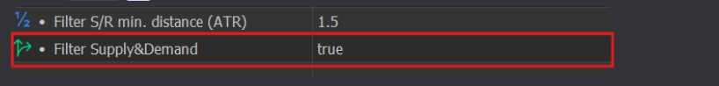
- The Supply & Demand (S&D) Filter controls whether the EA is allowed to use Supply and Demand logic as a trade filter.
  - When enabled, the EA monitors Supply and Demand zones during the monitoring and trading time windows. If Supply or Demand is present within these windows, the EA will prevent trades from being opened.
  - When disabled, the EA ignores Supply and Demand zones and evaluates entries using other active rules and filters only.
This setting allows you to decide whether the presence of Supply & Demand zones should block trade entries during the defined trading periods.

News Filter
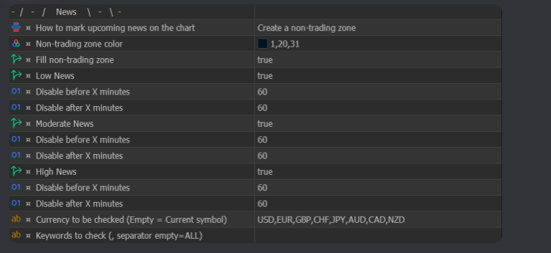
The News Filter allows the EA to avoid trading around economic news events, helping reduce risk during periods of high volatility. ---
How to Mark Upcoming News on the Chart
Defines how upcoming news events are visually displayed on the chart:
- Vertical line
- Non-trading zone
- Do not mark (no visual marking)
This setting affects visual display only and does not change trading logic. ---
Non-Trading Zone Color
Sets the color of the non-trading zone displayed on the chart when the filtering period is enabled. ---
Fill Non-Trading Zone
Enables or disables color filling of the non-trading zone on the chart for better visibility. ---
Low News / Moderate News / High News
Each option allows you to enable or disable filtering for:
- Low-impact news
- Moderate-impact news
- High-impact news
Only the selected impact levels will be considered by the EA. ---
Disable Before X Minutes
Defines how many minutes before a news event the EA should stop opening new trades, separately for each news impact level. ---
Disable After X Minutes
Defines how many minutes after a news event the EA should continue blocking new trades, separately for each news impact level. ---
Currency to Be Checked
Specifies which currencies should be checked for news impact.
- Leave it Blank for checking the currencies of the traded pair
---
Keywords to Check (Empty = All)
Filters news events based on specific keywords.
- Leaving this field empty means all news events are considered
- Entering a keyword (e.g., CPI) limits filtering to news events containing that keyword
--- This filter helps the EA avoid unfavorable conditions caused by economic announcements and sudden volatility

Trade Management
Partial Closing
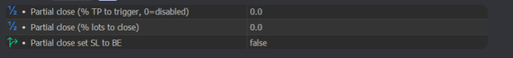
- The Partial Closing feature allows the EA to close a portion of a trade before the full Take Profit is reached, helping to secure profits and reduce risk. ---
Partial Close (% TP to Trigger, 0 = Disabled)
This setting defines at what percentage of the Take Profit the partial close should be activated.
  - If set to 0, partial closing is disabled
  - The percentage is calculated based on the total TP distance
When the specified percentage of the TP is reached, the EA executes the partial close. ---
Partial Close (% Lots to Close)
This setting defines how much of the position (in percentage) will be closed during the partial close. The remaining portion of the trade continues to run toward the original TP or SL. ---
Partial Close Set SL to BE
This option enables or disables moving the Stop Loss to Break Even after the partial close is executed.
  - When enabled, the SL is moved to the trade’s entry price
  - This helps protect the remaining position from turning into a loss
--- Partial closing is useful for locking in profits early while still allowing the trade to continue running.

Trailing Stop Mode
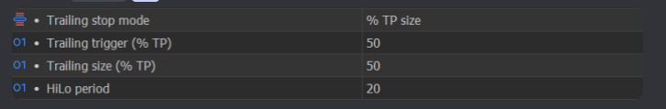
Trailing Stop Mode
This setting defines how the EA will trail the Stop Loss once a trade is in profit. Available options:
- Disabled – No trailing stop is applied
- % TP – Trailing stop is activated using a percentage of the Take Profit, similar to Partial Close logic
- HiLo – Trailing stop follows the Highest High (for buy trades) or Lowest Low (for sell trades)
---
Trailing Trigger (% TP)
Defines when the trailing stop should activate, based on the percentage distance between the entry price and the Take Profit. Once this percentage is reached, the EA starts trailing the Stop Loss. ---
Trailing Size (% TP)
Defines how far the Stop Loss will be placed once trailing is active, also calculated as a percentage of the Take Profit distance. Example : If a trade has:
- TP = 200 points
- Trailing Trigger = 25%
- Trailing Size = 50%
Then:
- Trailing activates at 25% × 200 = 50 points in profit
- The Stop Loss is placed 50% × 200 = 100 points away from the highest achieved profit and continues updating as price moves further in profit
---
HiLo Period
This setting applies only when HiLo trailing mode is selected. The EA checks the highest high or lowest low over the specified number of candles and uses that level to trail the Stop Loss. The Stop Loss will never be placed farther away than the Take Profit, ensuring controlled risk.

Grid System
Grid
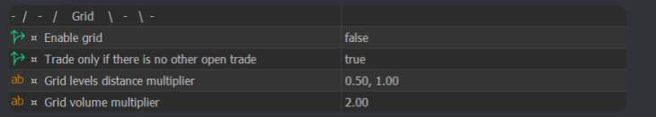

- The Grid feature allows the EA to open additional positions at predefined distances when price moves against the initial trade. This is used to improve average entry price and manage recovery logic. ---
Enable Grid
Enables or disables the grid trading system.
  - When enabled, the EA can open multiple grid positions based on the configured rules
  - When disabled, the EA trades with single entries only
---
Trade Only if There Is No Other Open Trade
When enabled, the EA will start a new trade only if there are no other trades already open on the account. The purpose of this setting is to guarantee sufficient free equity for future grid levels and prevent overlapping grids from multiple trades. ---
- Grid Levels Distance Multipliers
This setting defines how far apart each grid level will be placed, using the Take profit size as the base reference. The EA takes the TP size and multiplies it by the values entered in this field, step by step, to calculate the distance between each grid level. Example (as provided): If:
  - Take profit size = 200 points
  - Grid levels distance multipliers = 1.00, 1.50, 1.00, 2.00
Then:
  - 1st grid level: 200 × 1.00 = 200 points
  - 2nd grid level: 200 × 1.00 × 1.50 = 300 points from the previous grid level
  - 3rd grid level: 200 × 1.00 × 1.50 × 1.00 = 300 points from the previous grid level
  - 4th grid level: 200 × 1.00 × 1.50 × 1.00 × 2.00 = 600 points from the previous grid level
For subsequent grid levels, the last value in the string is repeated, causing the distance to increase indefinitely. To stop further distance expansion, place 1.00 at the end of the string. ---
Grid Volume Multiplier
This setting uses the same multiplier logic as Grid Levels Distance, but it is applied to the lot size (volume) of each grid trade. Each new grid position will have its volume multiplied according to the defined string. Important notes:
  - The multiplier string cannot be optimized
  - Users must choose reasonable static values
  - This setting has a direct impact on risk and drawdown
This option controls how aggressively position size increases across grid levels.

Capital & Prop-Firm Protection
Advanced Risk Management
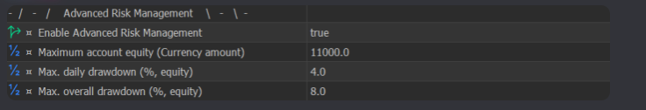

- The Advanced Risk Management module is designed to help traders—especially prop firm traders—comply with strict risk and drawdown rules by enforcing hard equity-based limits. ---
Enable Advanced Risk Management
Enables or disables the entire advanced risk management system. When enabled, the EA continuously monitors account equity and drawdown and applies the limits defined below. Important note: Advanced Risk Management only applies to trades opened by this EA, identified by its Magic Number. It does not close manual trades or trades from other EAs running on the account. ---
Maximum Account Equity
This setting defines a target account equity level. Important: You must enter your target balance (total equity value), not the target profit. Once the account equity reaches this value:
  - All trades opened by this EA are closed immediately
  - The EA stops trading
Example: If your account balance is $10,000 and your profit target is $1,000, you should set:
Maximum Account Equity = 11,000
(Not 1,000) ---
Max Daily Drawdown
Defines the maximum allowed drawdown per day, expressed as a percentage. Once the EA is started, it actively monitors account equity in real time. If the drawdown reaches the percentage set here:
  - All trades opened by this EA are closed
  - The EA stops trading for the rest of the day
This setting is essential for complying with daily loss limits. ---
Max Overall Drawdown
Defines the maximum allowed total drawdown, expressed as a percentage. If the overall equity drawdown reaches this limit:
  - All trades opened by this EA are closed
  - The EA stops trading completely
This protects the account from breaching maximum loss rules and from severe long-term drawdowns.

